# CS 340 README

## About the Project/Project Title

The Animal Shelter CRUD Dashboard is designed to manage data for an animal shelter using a MongoDB database. This project demonstrates how to Create, Read, Update, and Delete (CRUD) animal records within the shelter. It allows users to manage information such as animal type, breed, age, location, and rescue outcome. This application enhances the shelter’s operational efficiency by improving data management.

## Motivation

This project was developed to help animal shelters streamline their data management, enabling the shelter staff to store and retrieve animal records efficiently. It demonstrates how database operations can enhance the workflow in real-life scenarios by leveraging the MongoDB database and Python for efficient management.

## Getting Started

Get a local copy up and running, follow these simple example steps.

1.Set Up the MongoDB Database and User Authentication

2.Database Setup: You will need MongoDB installed locally or accessible as a cloud service. In this project, we used a local MongoDB instance with the database name AAC and a collection called animals.

3.User Authentication: set up an authenticated user (aacuser) with readWrite privileges for the AAC database. This ensures that only authorized users can modify or view data, enhancing security.

4. Clone the project repository

5. Ensure you have Python 3.9 or above installed.

6. Install the necessary Python packages using the command: pip install pymongo

## Installation

Tools used:

**Python 3.9**: You can download Python 3.9 from [python.org](https://www.python.org/downloads/).

**MongoDB**: Follow the installation instructions from [mongodb.com](https://www.mongodb.com/try/download/community).

**Dependencies**: Install dependencies by running pip install pymongo

## Usage

1. Update the connection parameters such as (host, port, username, password, database, and collection) in animal_shelter.py.
2. To run the script, use: python animal_shelter.py
3. The script allows you to insert new animal records and query the database for existing records.
4. Python driver for Mongo
5. PyMongo was chosen for its ease of integration with Python and MongoDB's

**Attributes**

1. Self client: Establishes the connection to the MongoDB client via PyMongo, enabling secure communication.

2. Self database: Connects to the AAC database, responsible for interacting with it.

3. self collection: References the animals collection within the AAC database, used to perform CRUD operations.

### Code Example

To create AnimalShelter and record a new animal record.

shelter = AnimalShelter(USER, PASS, HOST, PORT, DB, COL)

sample_data = {

"_id": ObjectId(),

"age_upon_outcome": "2 years",

"animal_id": "A123456",

"animal_type": "Dog",

"breed": "Labrador Retriever",

"color": "Yellow",

"date_of_birth": "2020-01-01",

"outcome_type": "Adoption"

}

shelter.create(sample_data)

### Tests

Going to launch Jupyter Notebook

Create a New Notebook or Use an Existing Testing Notebook called animal_shelter_testing.ipynb

Test Create Method:

from animal_shelter import AnimalShelter

from bson.objectid import ObjectId

# Define connection variables

shelter = AnimalShelter(USER, PASS, HOST, PORT, DB, COL)

sample_data = {

"_id": ObjectId(),

"age_upon_outcome": "2 years",

"animal_id": "A123456",

"animal_type": "Dog",

"breed": "Labrador Retriever",

"color": "Yellow",

"date_of_birth": "2020-01-01",

"outcome_type": "Adoption"

}

# Testing the 'create' method

insert_success = shelter.create(sample_data)

if insert_success:

print("Insert successful!")

else:

print("Insert failed!")

# Test data to be inserted into the MongoDB collection

sample_data = {

"_id": ObjectId(),

"age_upon_outcome": "2 years",

"animal_id": "A123456",

"animal_type": "Dog",

"breed": "Labrador Retriever",

"color": "Yellow",

"date_of_birth": "2020-01-01",

"outcome_type": "Adoption"

}

# Testing the 'create' method

print("Testing the 'create' method:")

insert_success = shelter.create(sample_data)

if insert_success:

print("Insert successful!")

else:

print("Insert failed!")

# Update Method

print("\nTesting the 'update' method:")

update_query = {"animal_id": "A123456"}

update_data = {"$set": {"breed": "Golden Retriever"}}

update_success = shelter.update(update_query, update_data)

if update_success:

print(f"Update successful! Documents updated: {update_success}")

else:

print("Update failed!")

# Delete Method

print("\nTesting the 'delete' method:")

delete_query = {"animal_id": "A123456"}

delete_success = shelter.delete(delete_query)

if delete_success:

print(f"Delete successful! Documents deleted: {delete_success}")

else:

print("Delete failed!")

If it works you should see the Insert Successful

Then follow suit for the Read method

### Screenshots

Rest

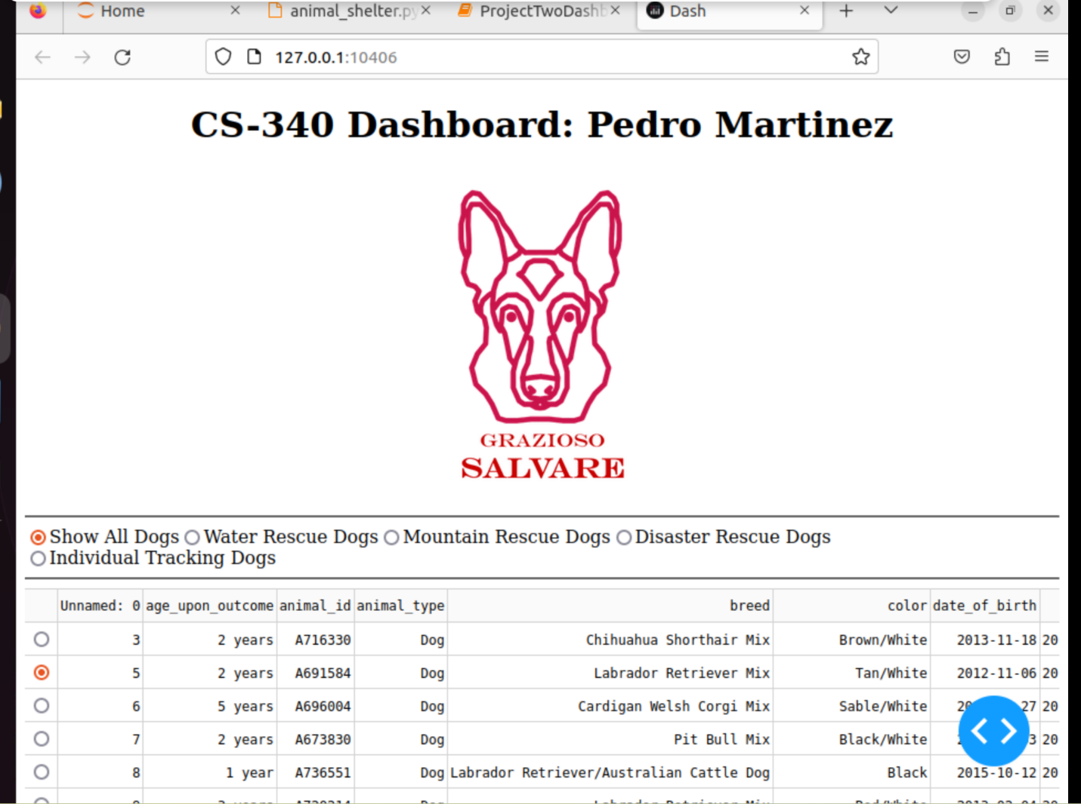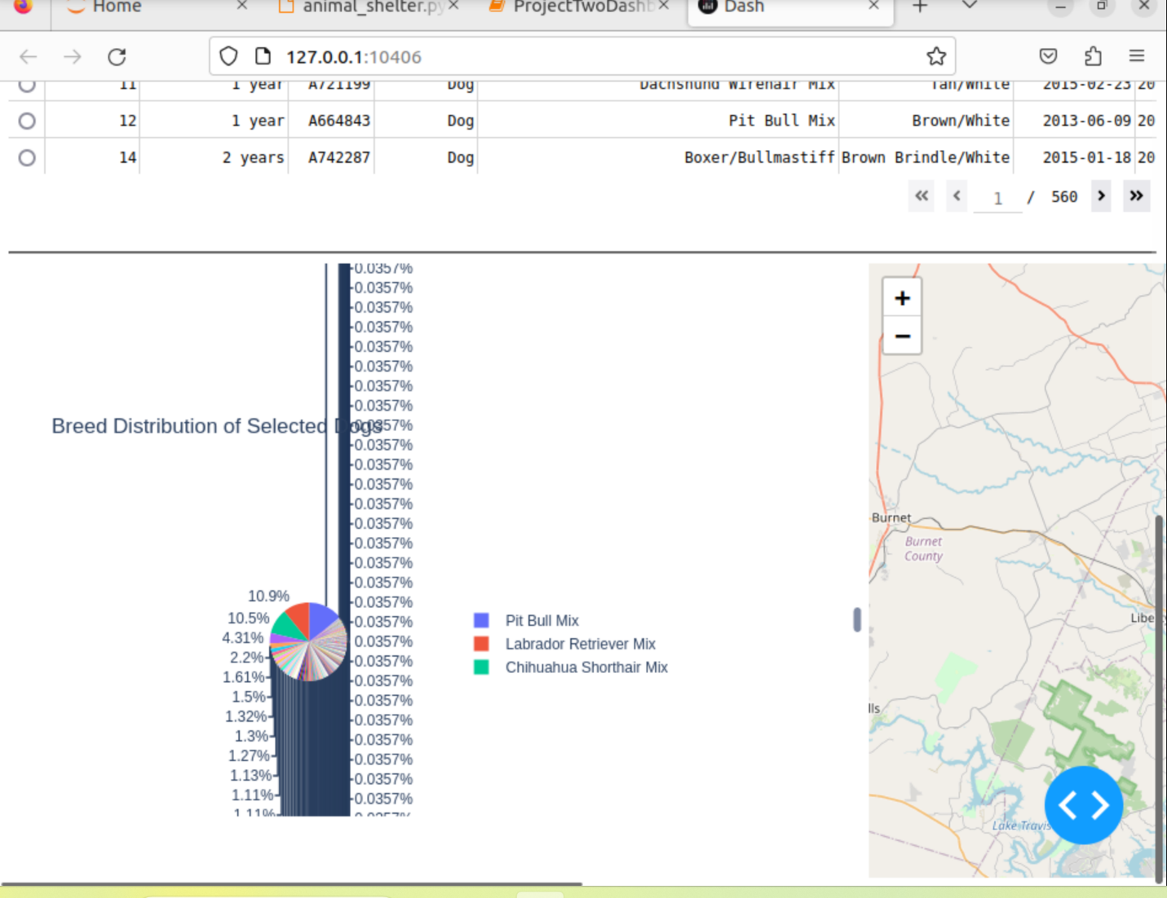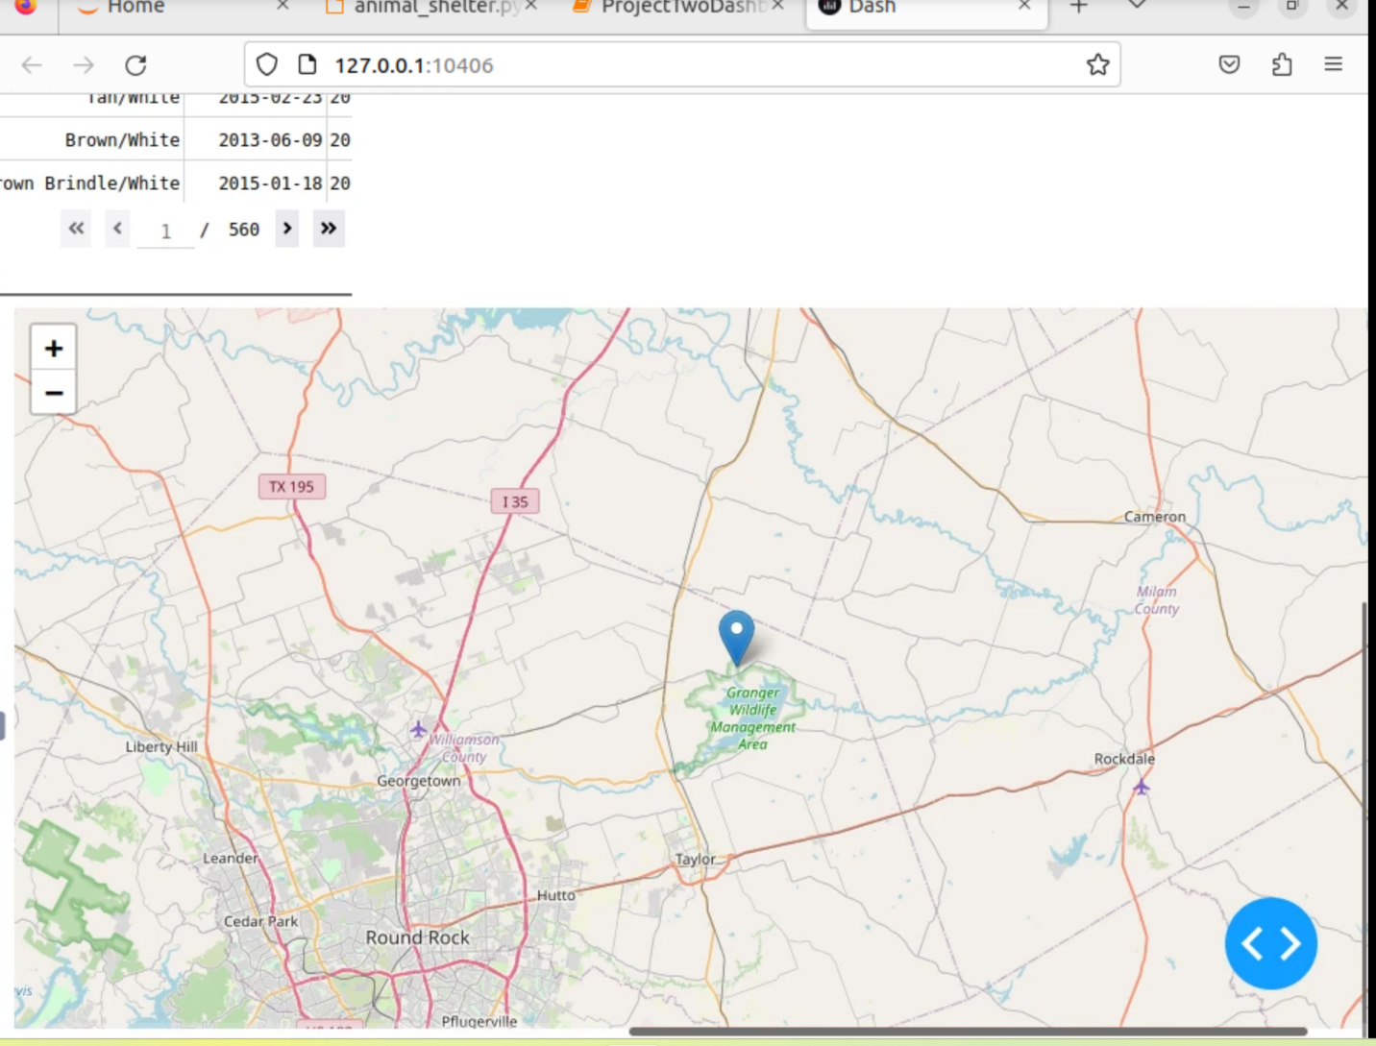

Water Rescue

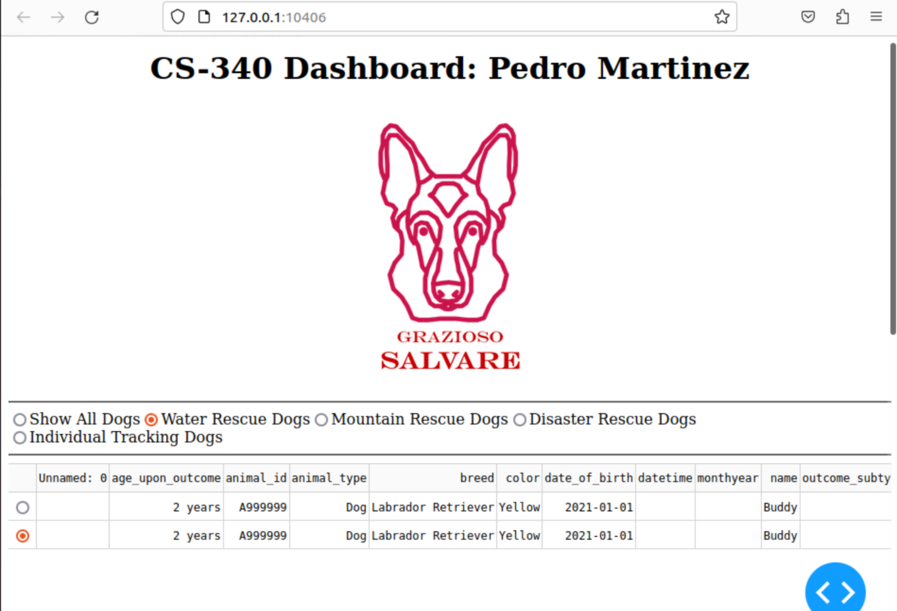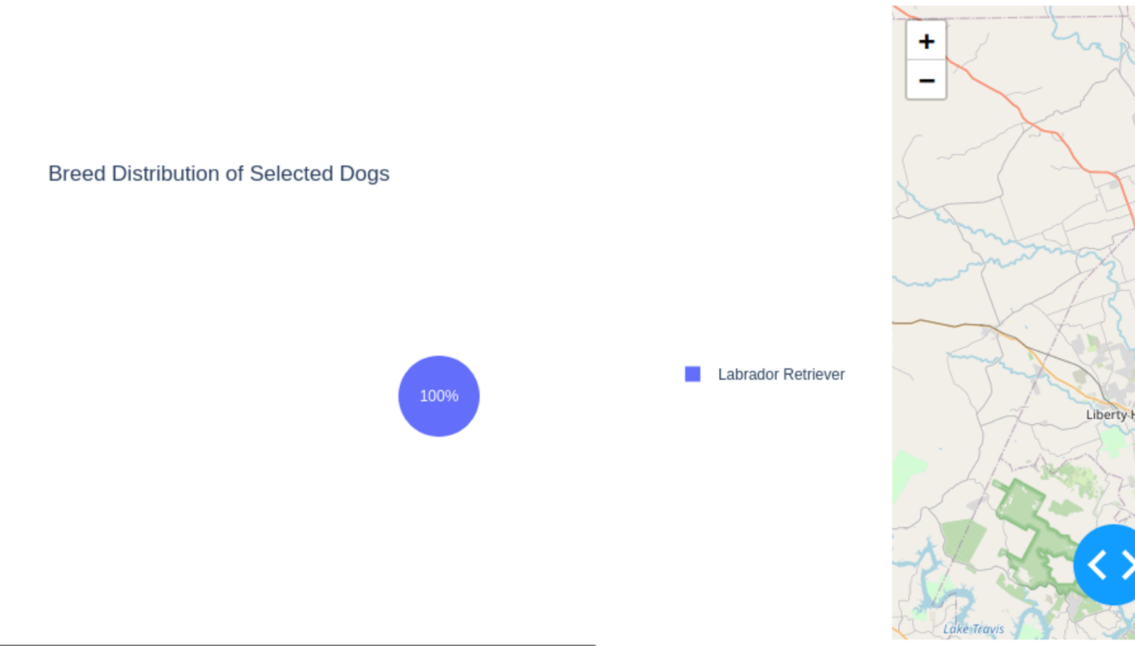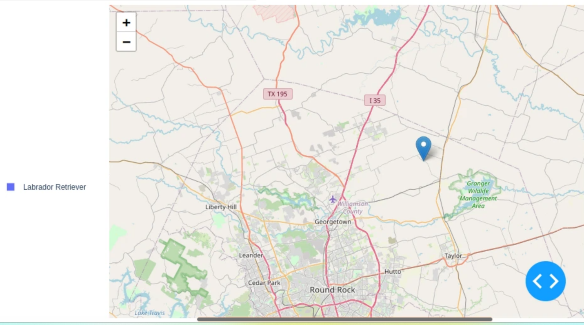

Mountain Rescue

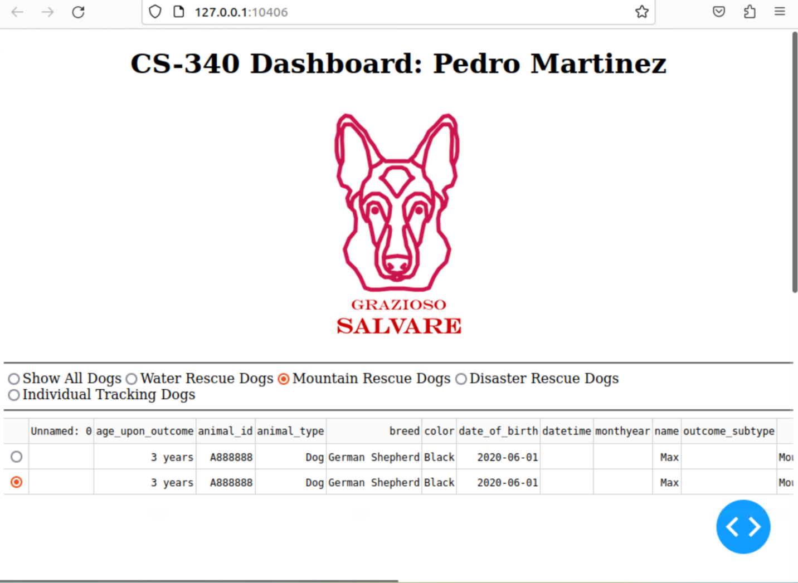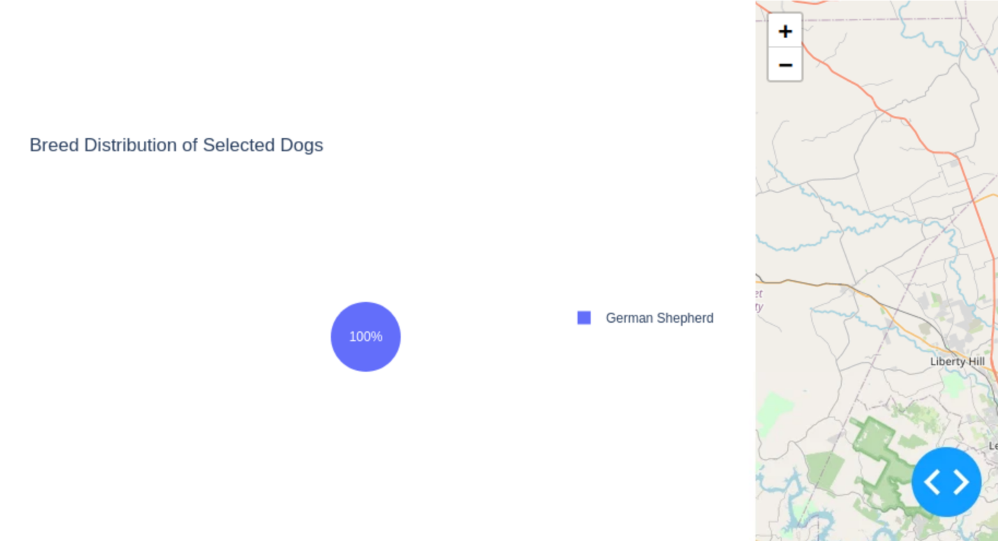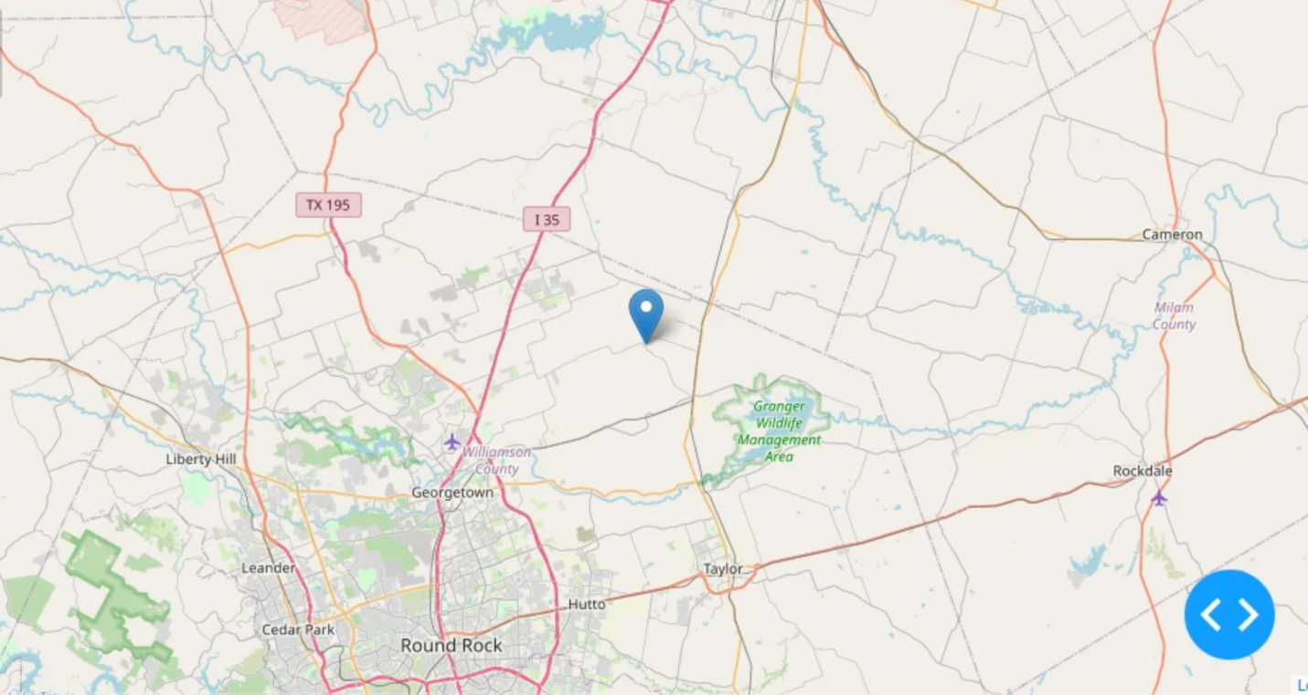

Disaster Rescue

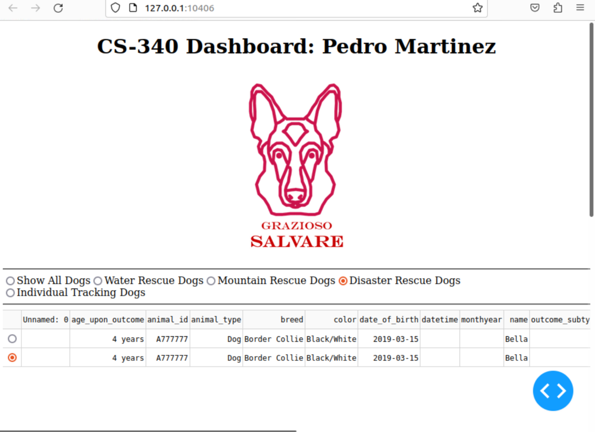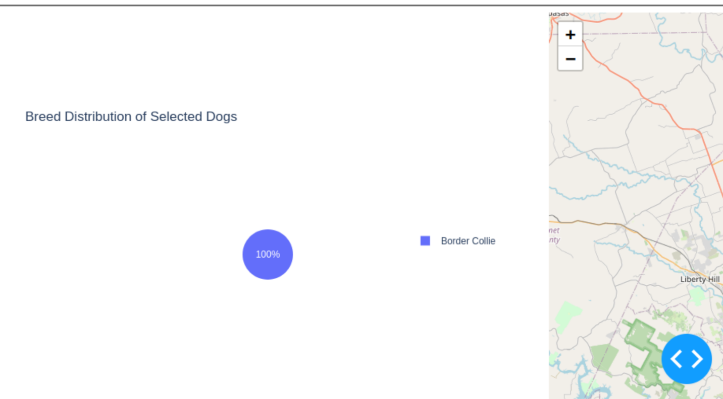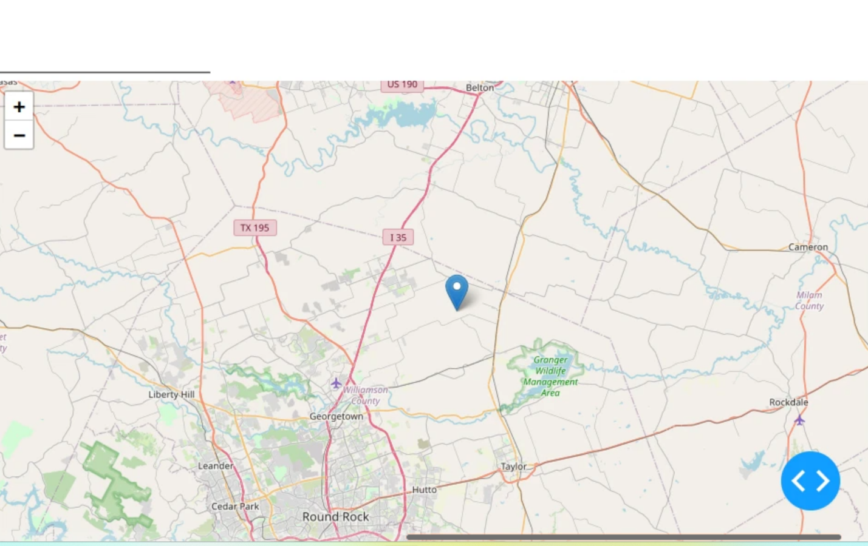

Individual Tracking

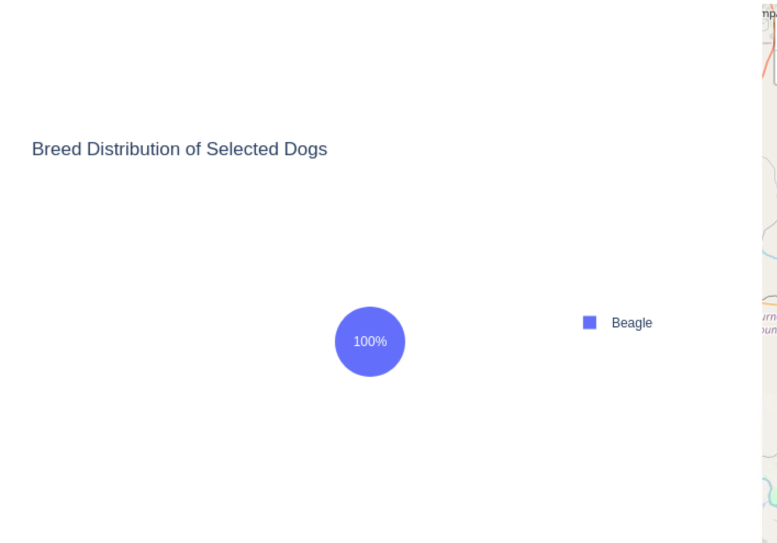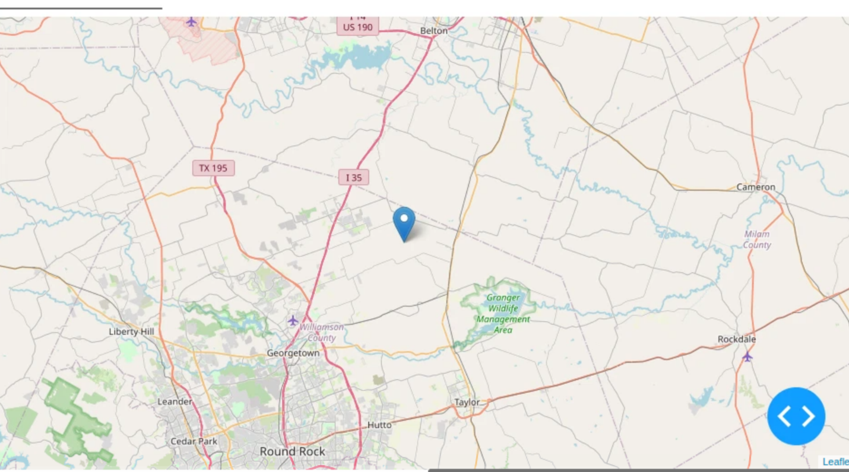

## Challenges:

Implementing the create and read methods required learning the specifics of MongoDB's insert_one() and find() functions through PyMongo. It was resolved by exploring the PyMongo documentation and testing in smaller parts to figure out each function. I was having a hard time for the update and it was a small error which took me a while to figure out.

## Contact

Your name: Pedro Martinez